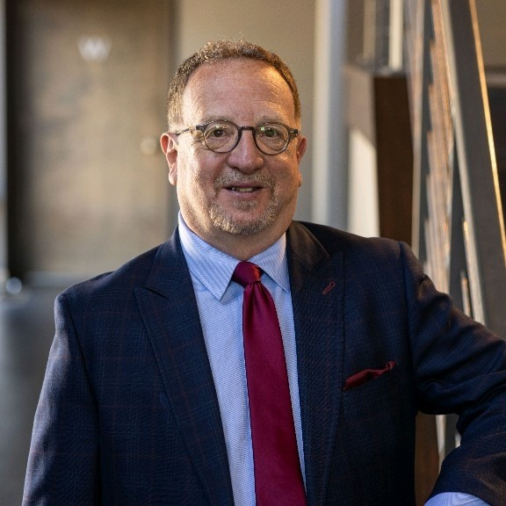
ATTORNEY JEFFREY A. CONEN
Hansen Reynolds, LLC.
301 North Broadway
Suite 400
Milwaukee, WI 53202
414-455-0056
Jconen@hansenreynolds.com
https://hansenreynolds.com/adr-booking

Biography:
I joined Hansen Reynolds LLC in 2020 after a 23-year career as a Milwaukee County Circuit Judge, in which I presided over 400 jury trials in both civil and criminal cases. Prior to serving as a Circuit Judge, I was elected Municipal Judge in the City of Glendale and was in private practice, handling a variety of civil and criminal litigation matters. My extensive background as a judge and experience in private practice gives me the unique ability to see the parties’ needs and interests from a neutral position in a wide variety of legal areas.
I have served on the faculty for the Office of Judicial Education for over 25 years and has taught judges in the areas of domestic violence, evidence, alternative dispute resolution, and a variety of civil litigation matters. I have a passion for finding alternative ways to resolve disputes in a quick and cost-effective manner.

Education:
University of Wisconsin-Madison (BS in International Relations and Political Science, 1982)
IIT-Chicago Kent College of Law (JD,1985)
Certificate in Mediation, Northwestern University (2020)
Bar Admissions:
State of Wisconsin
State of Illinois
Eastern District of Wisconsin
Western District of Wisconsin
Northern District of Illinois (Trial Bar)

Awards:
Special Commendation from the U.S. Department of Justice, Office on Violence Against Women.

Experience:
Presided over 400 jury trials in civil, misdemeanor, domestic violence, homicide, sexual assault and other felony matters.
12 Years in private practice.
Appointed to the Supreme Court of Wisconsin’s Judicial Education Committee and the Policy Planning and Advisory Committee, served as chairperson for Milwaukee County’s Jury Committee and its Video Conference Committee, and was a commissioner on Milwaukee’s Commission on Domestic Violence and Sexual Assault.
Interned for Judge John L. Coffey of the United States Court of Appeals for the Seventh Circuit.

